**DATABASE PROJECT**

**Assignment 1**

**First task:**

*Our project name:* Lost & Found

*Team members:*Kiara Mersini, Keid Mersini**,** Anxhela Mata &Lend Kalemasi

**Second task:**

The system is meant to help students manage lost and found items more efficiently within the university. From a user’s point of view, the main purpose of the application is to allow anyone who has lost or found an item to report it in a structured way and to make it easier for both parties to get matched. A student who lost something can log in and create a report with details such as item id, name, category, description, photo, date and location where it was lost. On the other side, someone who found an item can also file a report with similar details. Each report is tied to a status (Pending or Accepted) which will be managed by an administrator who verifies the information and ensures that only valid reports are stored.

For regular users (students), the interaction is simple: they can create, view and search reports to check whether their lost item has been found or whether something they found was already reported as missing. Students also have the option to track the progress of their reports as they move from Pending to Accepted.

For administrators, the system provides tools to verify and approve reports so that only accurate entries appear in the system. Admins also have the responsibility of updating the status of items to “Found” once they are returned to their owners. This ensures that the database always reflects the current situation of each case.

The goal of the application is to reduce confusion and give students one reliable place where they can report, track and resolve lost and found cases more easily.

**Third task:**

*ER Diagram Description:*

* **Entities and attributes:**

**User**: Email, Password

**Report**: ReportID, ReportDate

**Item**: ItemID, Name, Category, Description, Photo, DateLost, LocationLost

**Status**: Pending, Accepted

* **ISA hierarchies:**

User - Student, Admin

Report - LostReport, FoundReport

Item - LostItem, FoundItem

Status - Pending, Accepted

* **Relationships and multiplicities**

**creates**: A Student can create many Reports (1:n). Each Report belongs to one Student (n:1).

**describes**: Each Report describes exactly one Item (1:1). Each Item is linked to one Report (1:1).

**verifies**: An Admin verifies Items and sets their Status. One Admin can verify many Items (1:n). Each Item has exactly one Status at a time (1:1).

*ER Diagram Representation:*

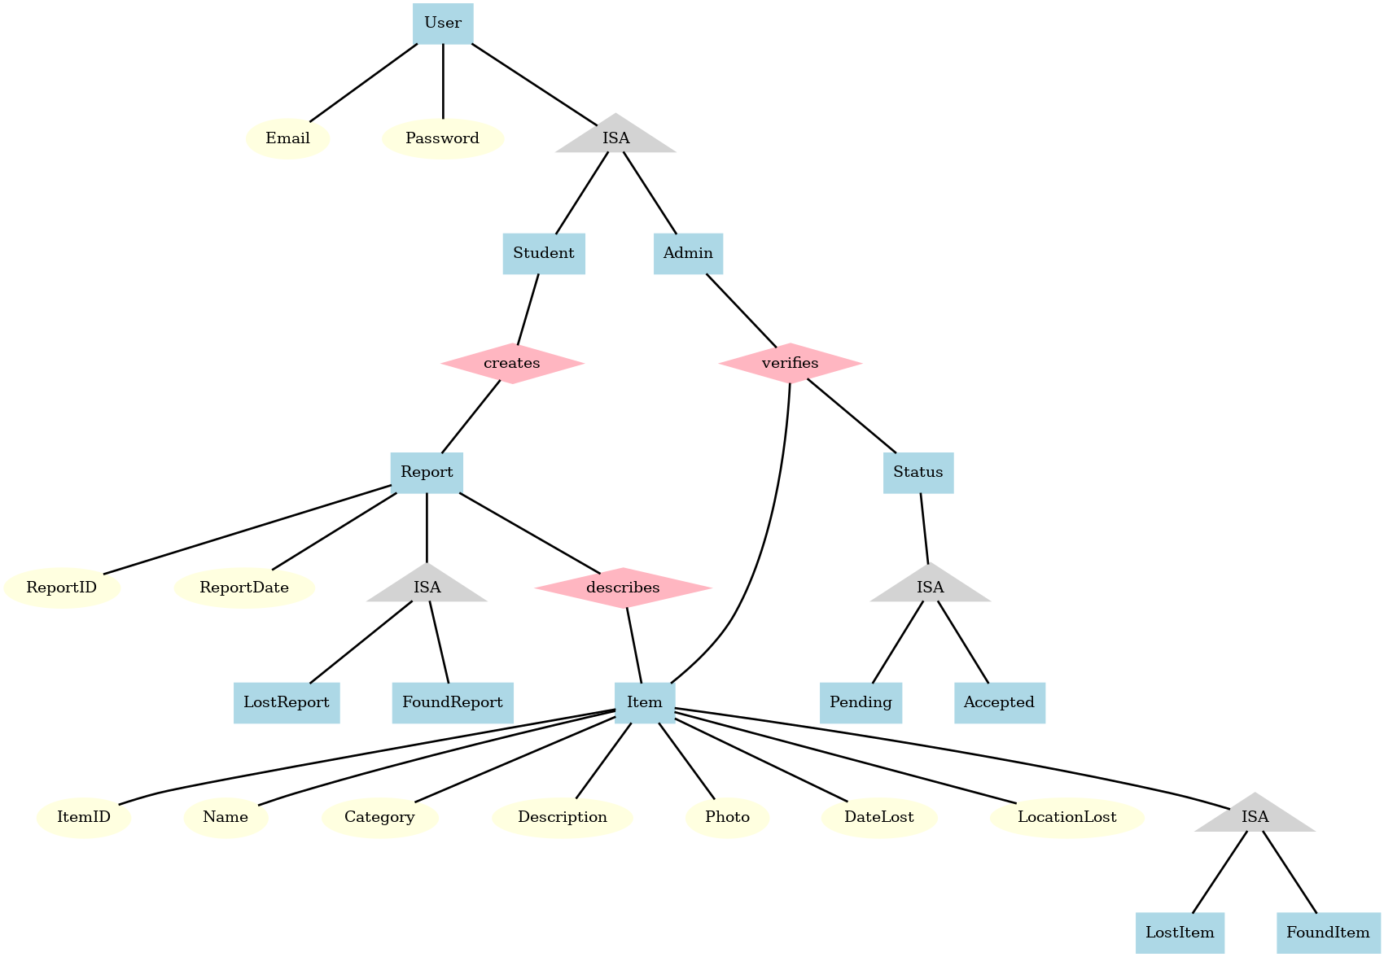

**Fourth task:**

*What the user sees:*

Student:

* + Login page with fields for email and password.
  + Dashboard with options to create a new report or view their past reports.
  + A form to submit details of a lost or found item (name, category, description, date, location, and optional photo).
  + A list of submitted reports showing their current status (Pending / Accepted).

Admin:

* + Login page.
  + Dashboard listing all pending reports from students.
  + Full details of each report and its associated item.

*What actions they can take:*

Student:

* + Log in / log out.
  + Create a LostReport or FoundReport.
  + Upload a photo of the item.
  + View the status of their submitted reports.
  + Search and filter existing reports.

Admin:

* + Log in / log out.
  + Review pending reports.
  + Accept a report
  + Reject a report if invalid.
  + Change the status of an item to Found once the owner confirms it.

*What their results are:*

Student:

* + New reports are stored in the system with status “Pending.”
  + Once the Admin verifies the report, the status changes to “Accepted.”
  + Successfully uploaded photos are stored alongside the report.

Admin:

* + Accepted reports become visible with updated status.
  + Rejected reports do not appear publicly.
  + Items marked as “Found” are closed in the system, showing they have been returned to their owner.

*What illegal input/actions can be:*

Student:

* + Wrong login credentials - access denied with error message.
  + Leaving required fields blank in the report form - system prompts to complete missing fields.

Admin:

* + Wrong login credentials - access denied.
  + Trying to re-verify a report that has already been processed - error message shown.

|  |  |
| --- | --- |
|  |  |